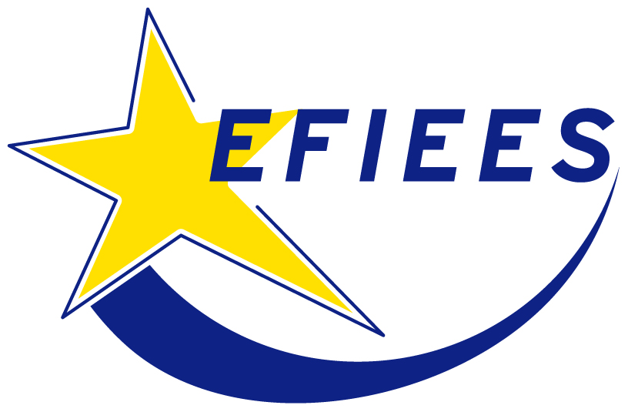

EUROPEAN FEDERATION
OF INTELLIGENT ENERGY EFFICIENCY SERVICES

FÉDÉRATION EUROPÉENNE
DES SERVICES EN EFFICACITÉ ET INTELLIGENCE ÉNERGÉTIQUE

29 February 2008
DRAFT

EFIEES represents private companies ensuring a global management of energy demand to end-user (Energy Efficiency Service Companies, EESCs). These companies provide operational services, running, maintaining and managing equipments on end users’ site: industrial, service, residential premises (collective or personal), public premises (sports, healthcare, hospitals …).

They commit, by long-term contract, to a set of technical, economic and environmental performance standards. Their remuneration is based on that performance commitment, defined as compliance with operating quality standards and/or delivery of improvements in energy efficiency.

EFIEES’ members represent 25 M tons of CO2 allowances in 13 Member States. They are active in District Heating as well as in outsourced combustion installations.

On 23rd January, 2008 the EC Commission adopted a proposal for a revision of the EU ETS Directive. The regime proposed for the heating sector, comprising district heating (DH) as well as industrial heating, with or without cogeneration, could allow for further development of this sector, provided that some amendments are made to the Directive. Further development of DH rather than individual heating, will contribute to global decrease of CO2 emissions.

The rules for CO2 emissions of DH, expressly covered in the Directive’s scope in its Annex I, should take in account: 1. risks of « carbon leakage » within the EU, due to market share losses from DH towards individual heating since the latter is not covered by CO2 constraints; 2. at the same time the EU should acknowledge the need to develop DH, because it is less CO2 emitting than individual heating.

Industrial heat production must be subject to non-discriminatory rules in order to ensure equal treatment of installations, whether operated directly by the industrialist or by a third party on his behalf.

1. Heat

Recitals 16 and 17 of articles 10 b 3 and 6 states that although the general rule will be 100% auctioning for electricity, and « other sectors » covered EU ETS - including DH and industrial heat – there will be a transitional system in place. The heat production would consequently be treated as an industrial sector.

But we highlight the need to remove the ambiguity resulting from the combination of the Recitals and the articles mentioned above with Annex I. This Annex classifies within the same category electricity production activities and heat production.

  - Amendment to Annex I « production of electricity and or heat »

Even more important: according to Recital 20 and article 10b 8, free allowances will be given to sectors that can prove their ”inability to pass on the costs of required allowances in product prices without significant loss of market share to installations outside the Community not taking comparable action to reduce emissions”.

DH networks suffer from a distortion of competition within EU, due to the fact that individual heating is non ETS-covered (ETS covers only installations over 20 MWh). But at the same time, individual heating is more CO2 emitting

  - Amendment: add to art 10. b 9 « … or within the EU ».

2. Cogeneration

Outsourced cogeneration: (is the definition of article 3 u) is applied to a manufacturer of paper or of chemical products that produces electricity in cogeneration. Outsourced cogeneration will not be considered as an « electricity producer », since it falls within the category of paper or chemical industry. It will consequently benefit from free allowances for electricity produced in cogeneration. But if the same electricity production happens with outsourced installations, meaning that a third party runs the cogeneration for same characteristics of direct/non direct use of electricity by the industrialist, it will qualify only as an «electricity producer », and therefore be subject to 100% auctioning of CO2 allowances.

This discrimination which is detrimental to externalised cogenerations must be deleted, as it would otherwise penalise also the connexion of industrialists to existing DH networks.

  - Amendment: add to u) a 3rd paragraph: « The delivery of electricity with feed-in tariffs shall not be considered as sale to third parties, unless feed-in tariffs contain an adjustment mechanism allowing to recuperate the price of CO2 allowances »

3. International aspects

Same discrimination is made to outsourced installations for heat production. They are excluded from the mechanism of CER and ERU, because of the notion of « operator » - outsourced installations will not be considered as “operators” as long as they are considered only as « electricity producers ».

  - Amendment: either by changing article 11 bis so that the provisions also apply to externalised installations, or a general amendment for the whole Directive – on article 3f and the definition of «operator »

4. Redistribution of money collected with auctioning:

Ask that 80 % of collected money through auctioning be redistributed to actions or projects aiming at reducing CO2 emissions, instead of 20% + 10 %.

